Software Requirement Specification

Intra-network Multiplayer Scrabble® Application

Maximus Latkovski

Jy’el Mason

David Carr

Samuel Costa

Ian Boyer

# Introduction

This section gives an overview of the Scrabble® requirements document, in addition to the scope description and intended audience of the project.

## 1.1 Purpose

The purpose of this document is to describe an online, multiplayer Scrabble® game application similar to that of the Hasbro game. This document will illustrate a mock-up representation of the user interfaces and describe the application constraints and fail safes. It will also explain the functions of which the application will be capable.

## 1.2 Scope

The Scrabble® game application is a desktop-based game application intended to connect 2 to 4 players at a time, with the host having multiple options to change how the game plays. This application is based on Hasbro’s game of Scrabble® and will include all the same rules. This application is also intended for the same audience, ages 8 and older, with the advantage of using software to eliminate the need for a physical board.

## 1.3 Definitions

| **Term** | **Definition** |
| --- | --- |
| **User Terms** | |
| User | A person who is using the software described in this document |
| Player | A player is a user who is actively participating in a Scrabble® game |
| Host | The host of a Scrabble® game is the computer that manages the game, including but not limited to communication with other players, timekeeping, and Scrabble tile bag queue management. |
| Host Application | The application which is designated as the host for the purposes of party management. This application oversees of the tile bag, timing for each player, and sending messages to non-host applications |
| **Game Terms** | |
| Board | A 15 cell by 15 cell interface upon which Scrabble® tiles are placed |
| Tile | A square containing both letter and letter value |
| Tile Bag | The data structure that holds the letters that will be played by the players during the game |
| Rack | The tiles which a player may use to make plays on their given turn. These tiles are drawn from the tile bag and will number 7 in total in a traditional Scrabble® game. |
| Cell | A spot on the playable board |
| Modifier Cells | Specific squares on the board that increase points made when words are placed on them |
| DL/Double Letter Cell | A light blue-colored cell which doubles the value of any tile placed on it |
| TL/Triple Letter | A navy blue-colored cell which triples the value of any tile placed on it |
| DW/Double Word | A pink-colored cell that doubles the value of any word on the first turn and has a tile placed on it |
| TW/Triple Word | A red-colored cell that doubles the value of any word on the first turn and has a tile placed on it |
| Letter | The character centered on the tile |
| Turn | A turn is a set period during which a player may pass, exchange either one of or all their tiles, or play tiles on the board |
| Letter Value | The numeric value on the bottom right corner of a tile |
| Word Value | The total value of a word. The individual tile scores calculate this score (see 4.5.2.5 for more details), with any modifier cells which were triggered on a turn. |
| Bingo | When a player uses all tiles on their rack |
| Turn Score | The total amount of points a player scores in each turn. This score consists of all word values, plus a 50-point bonus if a bingo is earned |
| Player Score | A player’s score is the cumulative points earned throughout their turns |
| Dictionary | List of acceptable words |
| Blitz Mode | A game of Scrabble® which has a lower timer countdown preset |

# Overall Description

Scrabble® is a tiled board game in which at least two players compete to score the highest point total with lettered tiles on a 15x15 square board;these tiles are placed on the board to create English words outlined in the Scrabble® dictionary. Players draw seven tiles from a pool at the start and replenish their supply after each turn. The application will host up to four online players and simulate a game of Scrabble®, adapting the traditional rules to a virtual setting where possible. Users can customize some game settings before starting, providing a more tailored experience.

## 2.1 Product Function

Our software will be a web-dependent simulation of Scrabble® that will allow players to customize their own game or play with the default rules set by Hasbro. The software makes it impossible for players to break the rules that were set before the game. When the game ends, the software will announce a winner, and after a set period it will disconnect all players from the network.

## 2.2 User Characteristics

The recommended age to play the game is 8 years old and up (reading age for kids). This game is intended for people who enjoy challenges and puzzles. There is no need for the user to play Scrabble® beforehand, as the software will provide all the necessary information about the game's rules and mechanics. Users may either take on the role of a host or simply engage in play. While the software requirements for the application playing as the host are more complex than that of a player, a user who decides to host needs only set the game rules prior to the start of the game. After this initial phase, the host user plays as any other player.

## 2.3 Constraints

1. For a game of Scrabble® to be played, at least 2 users must be connected to the same network using a laptop, desktop, or other device that meets the standards outlined in 3.2 (Hardware Interfaces).
2. The user must have a basic understanding of the English language.
3. Users must have access to a computer mouse, touch screen, or touchpad.
4. If a user is disconnected from the game, they will be unable to rejoin the game.
5. If the host disconnects, the game will end.

## 2.4 Dependencies

For the software to be able to run, the host and users must be using a safe, stable network. The software will be built on Java with the minimum required version of Java SE 16.

# 3. Interfaces

The game will feature a starting menu with buttons to “Play” or “Quit”. By selecting “Play”, players can host a Scrabble® game or join an ongoing Scrabble® party. By selecting “Quit”, the application will close.

A possible extension of these options is to include a “Settings” button; this option would allow users to change the audio and visual components of the game. Note that in-game rules are a possible extension for the host of a Scrabble® party, and are included for the host, but are not a part of the “Settings” menu.

## 

## 3.1 User Interface

3.1.1 Main Menu Screen: Displays a “Play”, “Settings”, and “Quit” button. When clicking the “Play” button, the user must be transitioned to the play screen. When clicking the “Settings” button, the user must be transitioned to the settings screen. When clicking the “Quit” button, the application must terminate.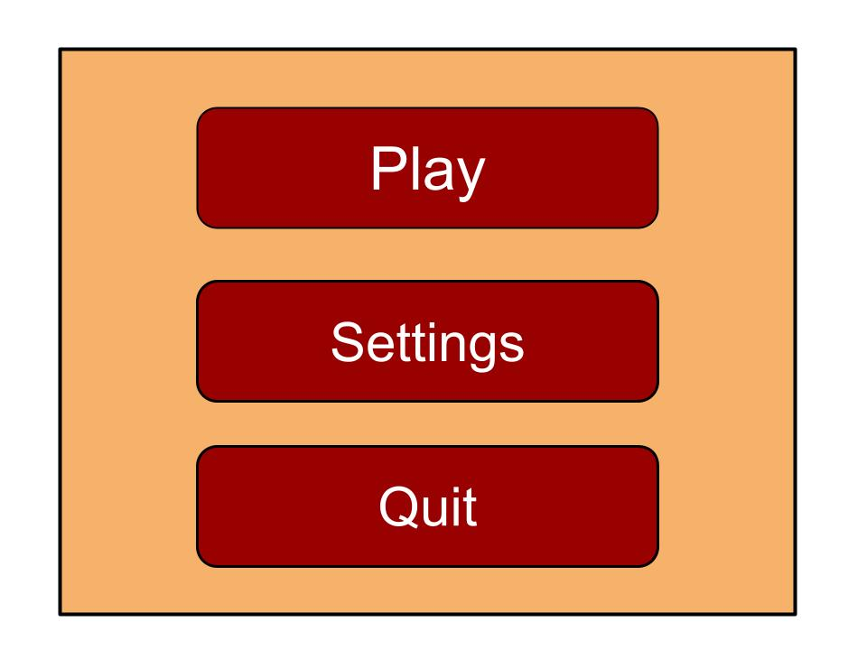

_______________________________________________________________

3.1.2 Settings Screen: This screen displays the options for the audio settings of the game. If the boxes next to “Game Audio” and “Audio FX” are checked, they must both be turned on. When the box is empty, they must both be turned off. When the user clicks the “Close” button, the user must be returned to the previous screen.

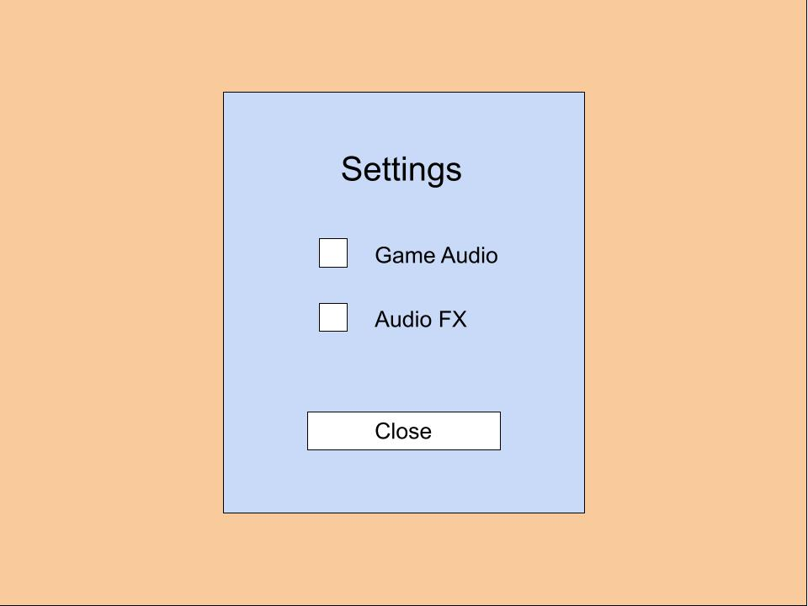

________________________________________________________________

3.1.3 Play Screen: This screen displays a button for “Join”, “Host”, and a back arrow button. A host must click the “Host” button which must transition them to the Host Screen. A player must click the “Join” button which must transition them to the Player Screen. When the user clicks the back arrow button, the user must be transitioned to the main menu screen.

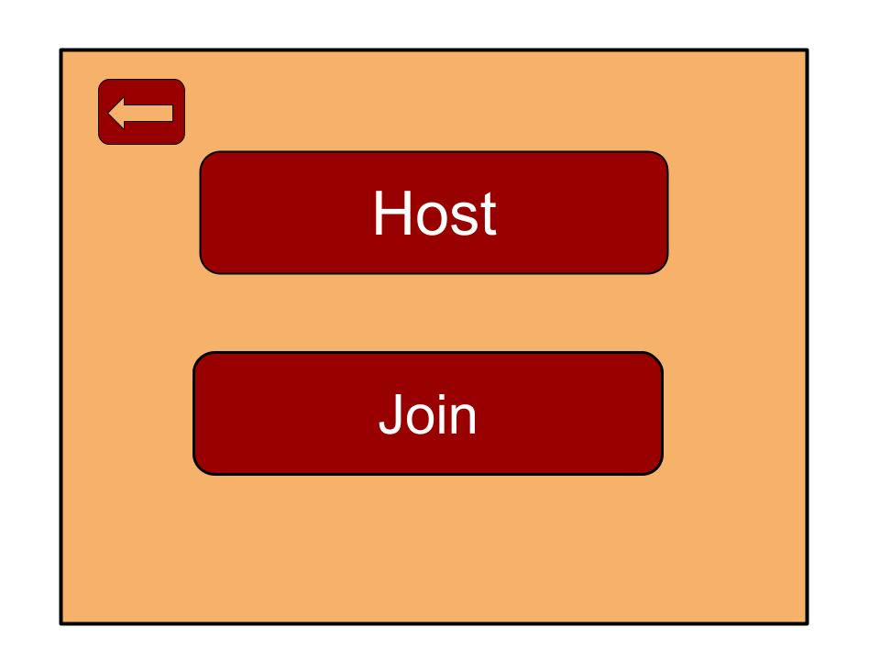

________________________________________________________________

3.1.4 Host Screen: This screen displays the host’s IP address, a textbox for the name, a player display, the “Play” button, and the back arrow button. The host will tell their IP address to the players for them to input. The host will type their name into the text box next to “Name:”. The player display will show the active players in the game. When clicking the “Play” button the host and all players will be transitioned to the rules screen. While not pictured, the host may have the option to change rules, which would be provided on this screen.

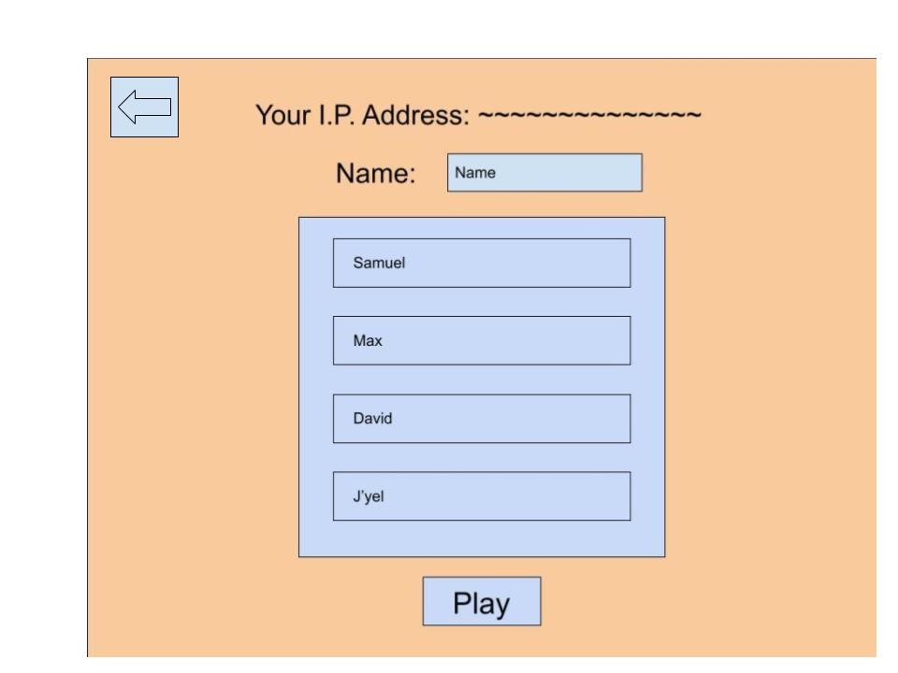

________________________________________________________________

3.1.5 Join Screen: This screen provides spaces for a player to enter a name to be displayed to other players and a space to enter the IP address of the host. Once this address field is filled, the player will have the option to “join” the party. They may also go back to the play screen at any time from this screen.

_______________________________________________________________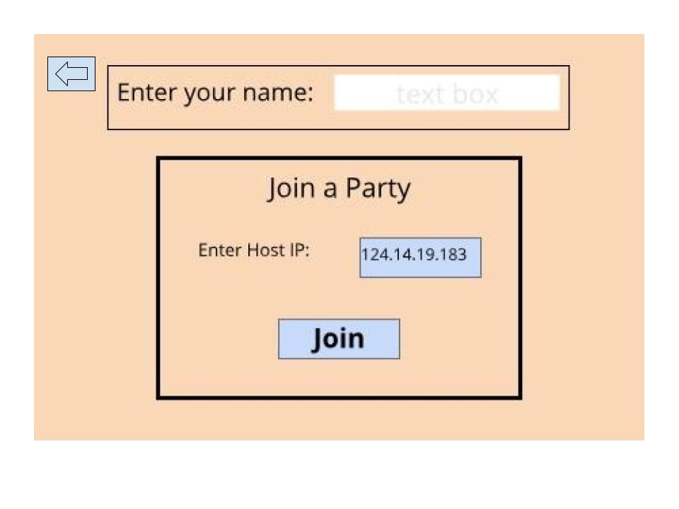

3.1.6 Player Waiting Screen: This screen displays the players actively waiting for the game to start.

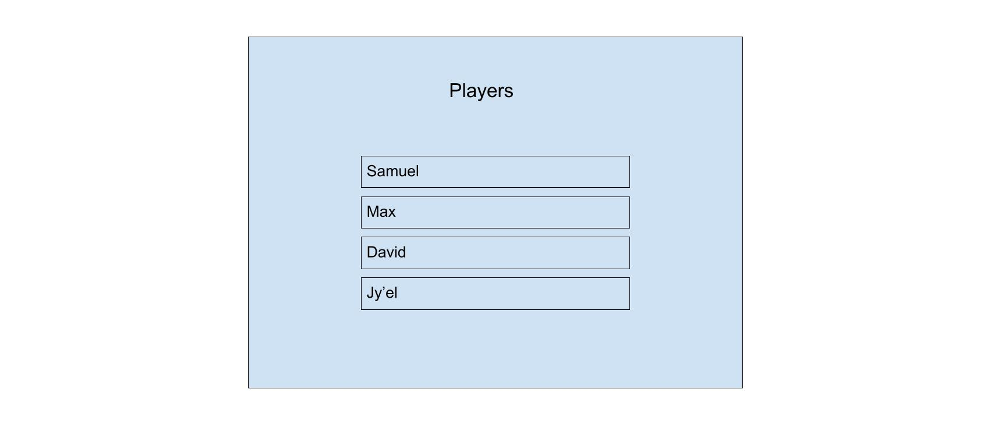

________________________________________________________________

3.1.7 Rules Screen: This screen displays a rules pop-up box over the Game Screen. The rules pop-up box must display the rules for the current game, set by the host prior to the game start. The “X” button in the top right corner must close the rules pop-up box and display the game board.

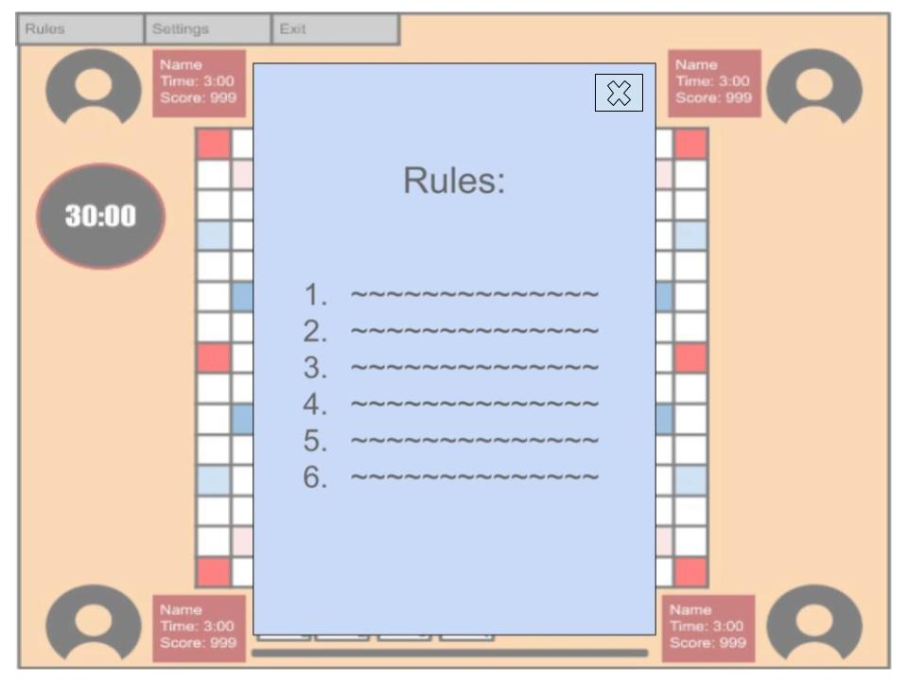

________________________________________________________________

3.1.8 Game Screen: This screen displays a button for “Rules”, “Settings”, and “Exit”. When clicking the “Rules” button, the rules pop-up box must appear. When clicking the “Settings” button, the user must be transitioned to the Settings Screen. When clicking the “Exit” button, the game must terminate. In the center of the screen is the 15x15 Scrabble® Board where the letter tiles will be played. The screen also displays icons for the players in the game with accompanying text boxes that show the player’s name, personal move time, and score. Also, there will be a game timer that shows how much time is remaining in the overall game. Finally at the bottom will be the rack of letters the user has available.

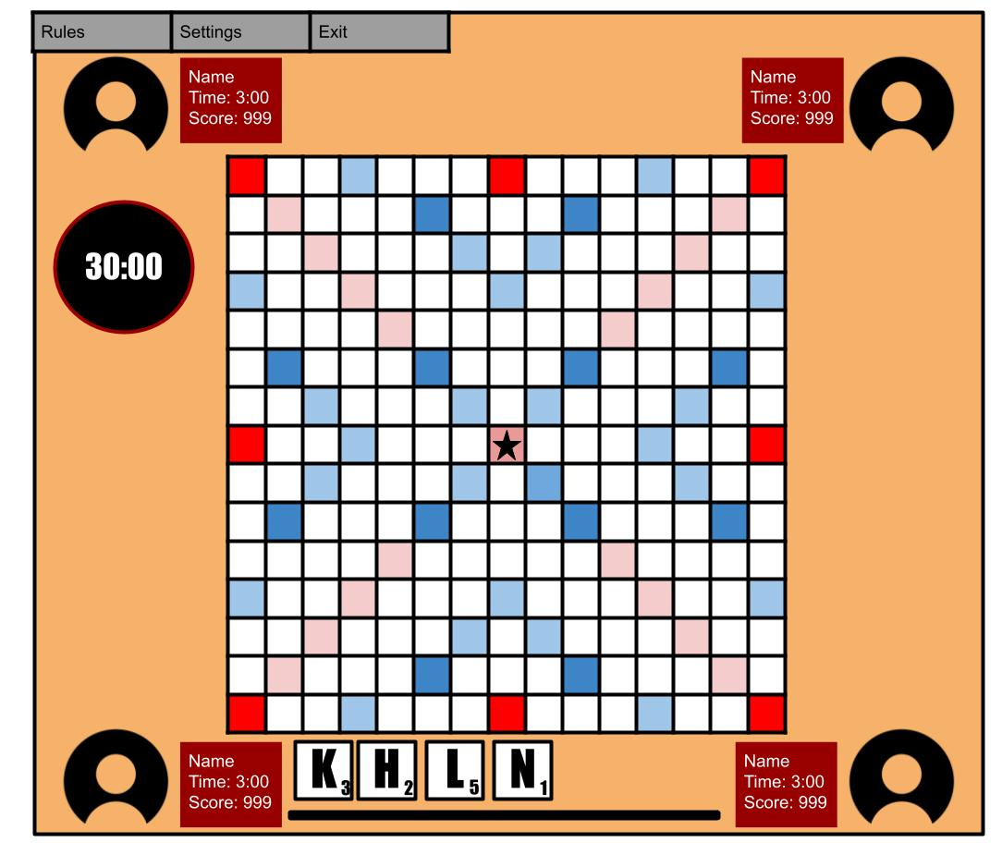

Scrabble® board: Each cell is one of 6 types:

* Blank: the value of the letter is as displayed on the tile.
* Start: tile where the first word must be placed. This cell has a 2x word multiplier associated with it.
* 2x Letter: Doubles the value of the letter played over the cell (light-blue).
* 2x Word: Doubles the value of the word played over the cell (pink).
* 3x Letter: Triples the value of the letter played over the cell (dark-blue).
* 3x Word: Triples the value of the word played over the cell (red).

________________________________________________________________

3.1.9 End Game Screen: This screen displays the final scores and placement of players, with an “Exit Game” button below. The podium is the ordered list of players from highest score to lowest which in turn shows the winner of the game at the top. When the “Exit Game” button is clicked, the user must be returned to the Main Menu Screen.

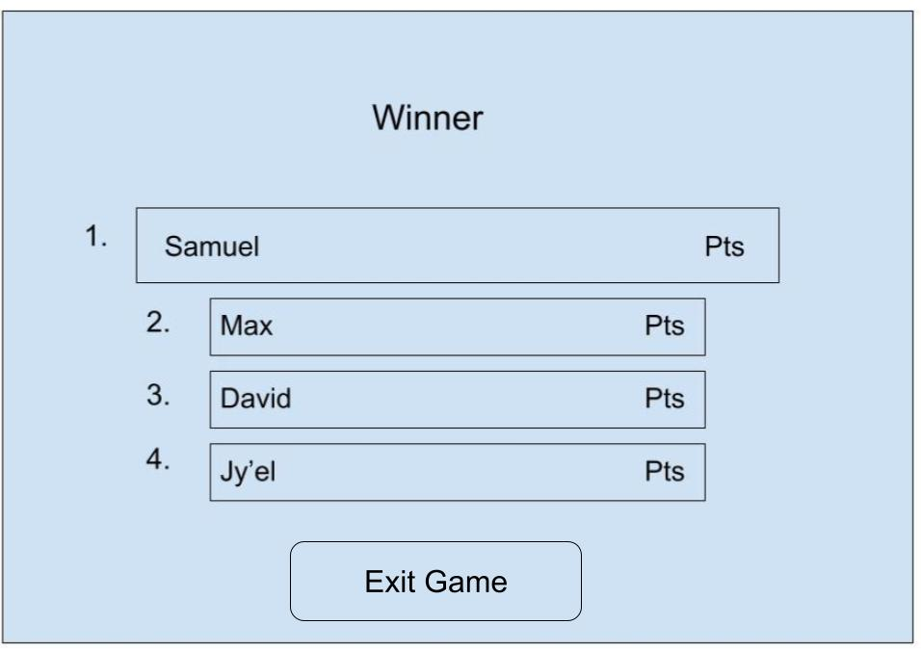

All figures above are to demonstrate planned user interfaces in addition to extended features. They are not representative of the final product.

3.2 Hardware Interfaces

1. Use of a keyboard for entering names and settings.

2. Use of a mouse, trackpad, or touch-screen to interact with tiles and game interface.

3. Use of headphones or speakers to listen to the game soundtrack and sound cues.

4. Use of at least a standard high-definition monitor (1280×720 pixels). Higher definitions should be supported.

## 3.3 Software Interfaces

1. Software will run on Windows.

2. Software will be built on Java with the minimum required version Java SE 16.

3. The application will utilize a local IP network to enable multiplayer gameplay. If a player disconnects, the game will reshuffle the player’s tiles back into the tile bag.

## 3.4 Communication Interfaces

The application will use TCP/IP to send and receive messages between users’ computers.

# Functional Requirements

## User Requirements

* + 1. The application must display the options “Play” and “Quit” when it is opened.
    2. The application must allow users to select between hosting a game and joining a game when the “Play” option is selected.
    3. The application must display the user’s IP address when the “hosting” option is selected.
    4. The application must have a text box to enter the host’s IP address when the “join a game” option is selected.
    5. The game host must be able to kick out players once they have joined.
    6. The game host must be able to start a game when at least one other player is present.
    7. Users must be able to leave a game at any time.
    8. The application must display the game’s rule set immediately after the host has started the game.
  1. Connection Requirements
     1. The host application must ensure that players are still connected.
     2. The host application must assure other players that they have not disconnected from other players.
     3. The host application must inform other players if a player disconnects.

## The Start of the Game

* + 1. The host application must shuffle the letter bag at the start of the game.
    2. The host application must reshuffle the letter bag only when a player disconnects or chooses to exchange a tile or all of their tiles from their hand (outlined below).
    3. The host application must assign seven letters to each player from the letter bag.
    4. The host application must randomly assign the order in which players take turns.
    5. The application must enforce the order in which players take turns.
    6. The application must require the first person to play a word on the star tile (near the center of the board).
    7. Players must play in the predetermined order, starting from the top of the order once all players have taken their turns.
    8. Player’s total score must be displayed below their name.
    9. Tile value must be displayed on the bottom right corner of the tile.
    10. Word value must be doubled when one of its letters is placed on a pink cell.
    11. Word value must be tripled when one of its letters is placed on a red cell.
    12. Letter value must be doubled when it’s placed on a light-blue cell.
    13. Letter value must be tripled when it’s placed on a dark blue cell.
    14. Newly placed tiles must connect to old tiles.
    15. A game must have a minimum of 2 players.
    16. A game must have a maximum of 4 players.
    17. The game board must be 15 by 15 cells.
  1. Game Timer
     1. The application must limit the length of time a player may use on their turn.
     2. The in-game timer must countdown from the set time to zero seconds.
     3. The player’s turn must end in a “pass” if they run out of time. (The “pass” mechanic is described in the “A Player’s Turn” section.)
     4. The application must restart the timer for each player, for each turn.
  2. A Player’s Turn
     1. A player must end their turn by
        1. a) placing letters on the Scrabble® board;
        2. b) passing their turn;
        3. c) exchanging either one of their tiles or all of their tiles.
     2. For option a:
        1. A player must place tiles on the board so that they create only valid words.
        2. A player must place only their own tiles on the board.
        3. Letters placed on a turn must have the same row value or column value. (Letters cannot be played diagonally, nor may a player place letters orthogonally.)
        4. The application must score the word(s) played on the turn.
        5. The application must score words using the applicable letter values and modifier cell(s). Modifier cells are applied only on the turn in which a tile is placed on it and not for any subsequent turns. Modifier cells which apply to letter values are evaluated first, then word value multipliers are applied.
        6. The application must add an additional 50 points to the player’s turn score if they score a bingo.
        7. The application must add the player’s turn score to that player’s total score.
     3. For option b:
        1. The application must allow a player to pass their turn without playing a word
        2. The application must disallow a player from placing letters on any subsequent turns if they pass two consecutive turns.
     4. Option c is a possible extension to the application. If it is implemented, it must adhere to the following requirements:
        1. The player must choose to exchange one of their tiles or all of their tiles.
        2. The player must choose which tile to exchange if they choose to replace one tile.
        3. The application must notify the host of the player’s choice.
        4. The host application must assign the appropriate number of tiles to the player, add their tiles to the bag, and shuffle the bag.
  3. Scrabble® Tiles
     1. The application must include letter tiles in the appropriate distribution, outlined below.
        1. 2 blank tiles (scoring 0 points)
        2. *1 point*: **E** ×12, **A** ×9, **I** ×9, **O** ×8, **N** ×6, **R** ×6, **T** ×6, **L** ×4, **S** ×4, **U** ×4
        3. *2 points*: **D** ×4, **G** ×3
        4. *3 points*: **B** ×2, **C** ×2, **M** ×2, **P** ×2
        5. *4 points*: **F** ×2, **H** ×2, **V** ×2, **W** ×2, **Y** ×2
        6. *5 points*: **K** ×1
        7. *8 points*: **J** ×1, **X** ×1
        8. *10 points*: **Q** ×1, **Z** ×1

(from [https://en.wikipedia.org/wiki/Scrabble ®_letter_distributions](https://en.wikipedia.org/wiki/Scrabble_letter_distributions))

* 1. Blank Tiles
     1. The application must allow blank tiles to be placed on the board.
     2. The application must prompt a player to choose a letter for the blank tile when they place it.
     3. The blank tile must have the selected letter displayed on it.
  2. Valid Words
     1. The application must contain the complete TWL Scrabble® dictionary of valid words.
     2. The application must validate each word which is played against the Scrabble® dictionary.
     3. The application must notify a player if the tiles placed do not create a valid word.
     4. The application must continue the player’s timer while the validation is ongoing.
     5. The application must not end a player’s turn when a non-valid word is played.
     6. By default, the application will allow only valid Scrabble® words to be played on a turn. A possible extension to the application is to allow players to have a “challenge” option in-game. If this option is implemented, it must adhere to the following requirements:
        1. The application must include a “challenge words” option in the rules before the game.
        2. The application must allow any set of tiles to be placed on the board.
        3. The application must allow players to challenge placed words.
        4. Challenges must validate each word played on the previous turn.
        5. Challenges must be issued only for the most recent play; they may not be issued for turns that took place before any other turn.
        6. A challenge fails when a player plays an invalid word or passes when each word played is valid.
        7. The application must subtract the turn score from a player who failed a challenge.
        8. The application must disallow a challenging player from playing their next turn if the challenge is passed.
  3. End Conditions
     1. The game ends if one of the following conditions is met:
        1. The players use all Scrabble® tiles in the bag.
        2. All players consecutively pass their turn.
        3. The host disconnects from the server.
     2. In the first and second cases, the application must display the final total scores of each player.
     3. In the third case, the application must notify all players that the host has disconnected.

# 5. Non-functional Requirements

## 5.1 Performance Requirements

The application should support up to four simultaneous online players. The computer should have a minimum connection speed of 30 kbps.

## 5.2 Safety Requirements

If a player disconnects in the middle of the game, the application should alert the rest of the players, return the disconnected player tiles to the “bag” of tiles, and remove the player’s information from the board so the other players know they were disconnected and ensure data consistency. Furthermore, the application will be self-contained to ensure the protection of the user’s systems.

## 5.3 Security Requirements

User data and game state should be accessible to any user with an application downloaded as there are no anticipated bad actors.

## 5.4 Software Quality Requirements

The in-game interface should provide easy-to-read metrics on time remaining, score, and names for each player. Each player should have only their letters on screen but should see how many letters there are for other players.

The application should be able to handle increased user load and additional features in the future. Additionally, the application must not crash. Alternatively, a crash in communication will always be allowed because there is no substantial impact on the software.

Extensions:

* A setting screen accessible to users that will contain:

1. Optional music toggle
2. Optional music volume level
3. Optional SFX toggle
4. Optional SFX volume level

* Fade-in and Fade-out Transitions between screens for better user experience.
* Rule set modifications: the host will be able to set the amount of time allowed per turn, change the dictionary, change the total amount of time the game will take, and allow or disallow the challenge mode.
* Challenge mode: as described in 4.8.6, a challenge mode will allow players to make non-valid word plays, which other players must then challenge to remove from the game board.